Step-by-step introduction to the MI Trainer Online Software
This guide explains how to use the “MI Trainer” online software for interviewing a Virtual Patient. This guide will not explain the tenets of Motivational Interviewing, and it is not strictly necessary to be familiar with MI in order to use the software or conduct the interview.
If you experience any technical issues, or have questions about the use of the software, please contact Richard Leibbrandt (co-facilitator of the workshop) at richard.leibbrandt@flinders.edu.au.
Create an account
Go to https://aqueous-depths-46462.herokuapp.com/, and create your account by clicking on the "Create an account" link at the bottom of the page. This will take you to the sign-in page. Here, you are asked to provide your first name and family name, email address and password. The email address and password will be used as your login details.
The registration process requires you to provide only this information. No registration email will be sent to the address you provided, and you will be able to login immediately.
Begin using the MI Trainer
Revisit https://aqueous-depths-46462.herokuapp.com/ (or click on the Login link after registration). This page will now allow you to log in to the site.
Once logged in, you will be presented with a screen similar to the one below.
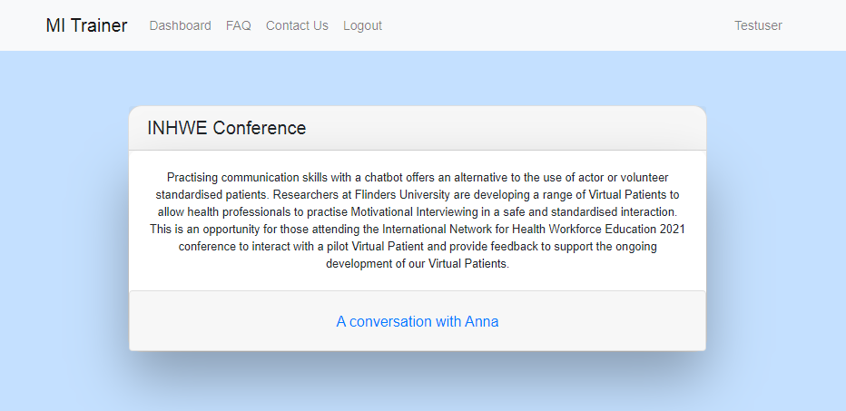
Conducting a conversation with MI Trainer
The MI Trainer allows users to conduct a “virtual interview” with a simulated client or patient. The interview explores the issues around weight loss and healthy diet experienced by “Anna”, a 60-year-old woman who has come to you to talk about managing her diabetes.
The interview consists of a series of conversational “turns”. When it is your turn, you as the health professional will choose the words that you will “say” to the virtual patient Anna. Once you have “said” your words, Anna will take her turn to respond appropriately with words of her own. The words in the conversation are not spoken aloud, but appear as text on the screen.
In your turn, you will select the next thing to say to Anna from a set of multiple-choice options (usually a set of four). Each of these options was devised by us when we developed the interview, and they represent a spectrum from completely adherent to MI best practice, through neutral, to completely in conflict with MI principles. (The software system allows teachers to easily create their own conversations. We have not made this capability available for standard users, but we will demonstrate it to participants during the workshop session.)
Before seeing the set of options, however, you will first be required to type in exactly the words that you believe would be appropriate to say to Anna. The multiple-choice options will appear only after you have submitted your text.
Please be aware that Anna will respond only to the multiple-choice option you have chosen from the set of remarks, and not to the text you have typed in. The reason why we ask for typed-in text as well is twofold. The primary reason is to support learning, by offering the student of MI the opportunity to formulate their own thoughts and feelings about what they should be saying, before seeing the suggested options. Our secondary purpose is to collect data about what students believe to be “the right thing to say” at each juncture, both for textual analysis and to support the development of artificial intelligence techniques that can begin to respond intelligently to typed-in text instead of our preformulated options.
It may be easiest to understand the process by stepping through an example, as we will do in the next section.
An example conversation
Click on the link “A conversation with Anna”, and then click on the button “Start Conversation” to commence using the MI Trainer.
You will receive a warning message to inform you that you need to continue with the conversation to the end as you will not be able to save it halfway and continue later. Click on “Start” if you are ready to commence.
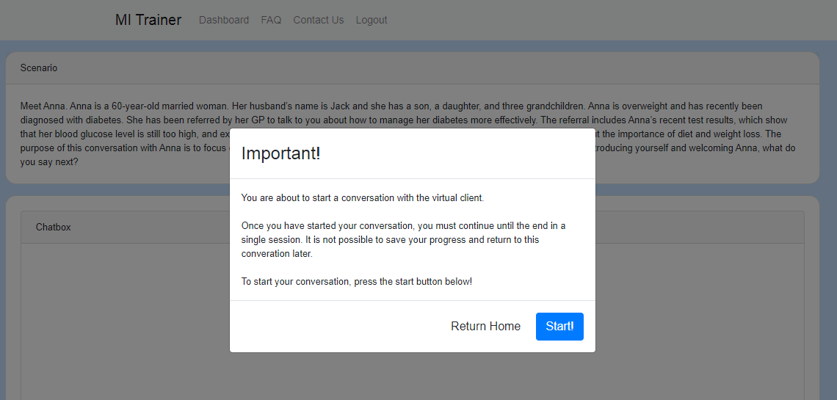
The conversation screen will start up. It will appear as in the following screenshot, which gives a brief case summary of the patient “Anna” who will be interviewed.
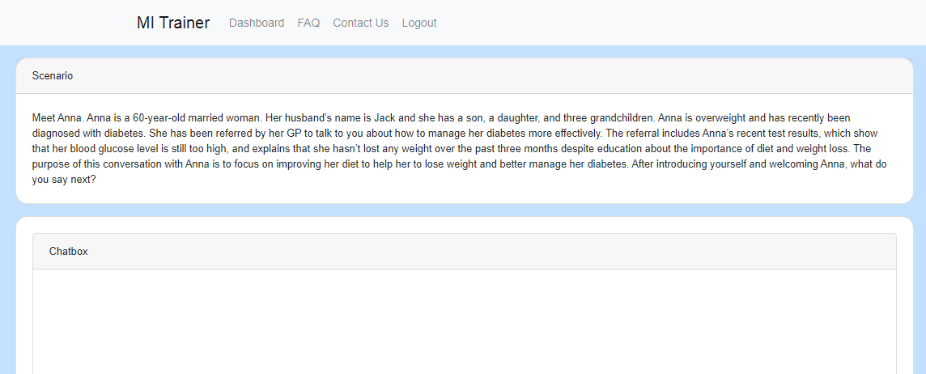
Now you can commence the interview. At the bottom of the page, you will see a text box in which you should type in the words that you would like to speak to Anna at this point.
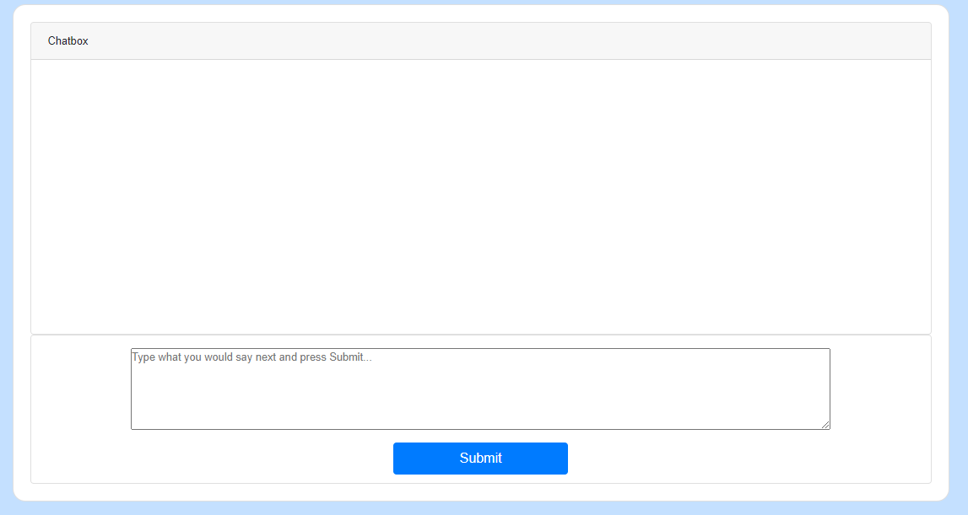
For the sake of the example, we will initiate the conversation by typing in “Anna , I am concerned about these results that your GP has sent through and I think we should discuss them today”. We encourage you to formulate your own words and enter these in. Once you are done, click on the “Submit” button.
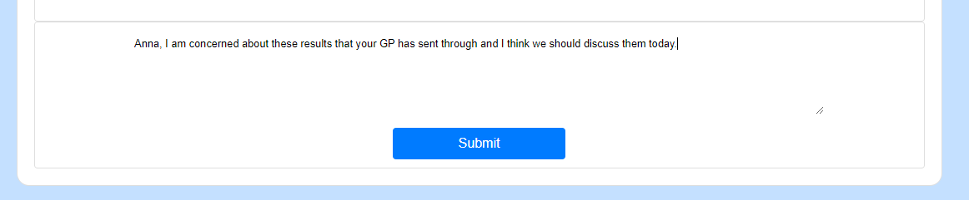
Once we click on Submit, a set of four options appears.
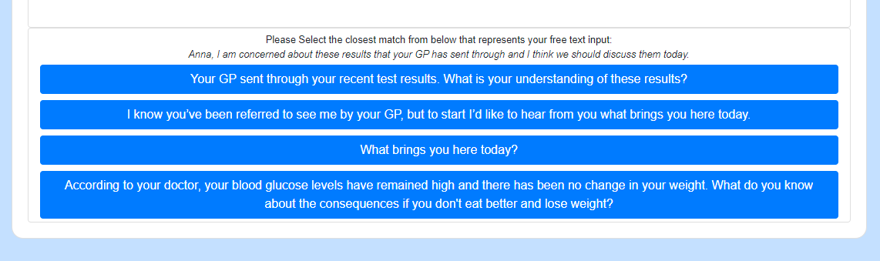
Suppose that we choose the last of the four options (starting with “According to your doctor…”). When we click on this option, it is selected and Anna responds accordingly. This is displayed on-screen as in the following screenshot:
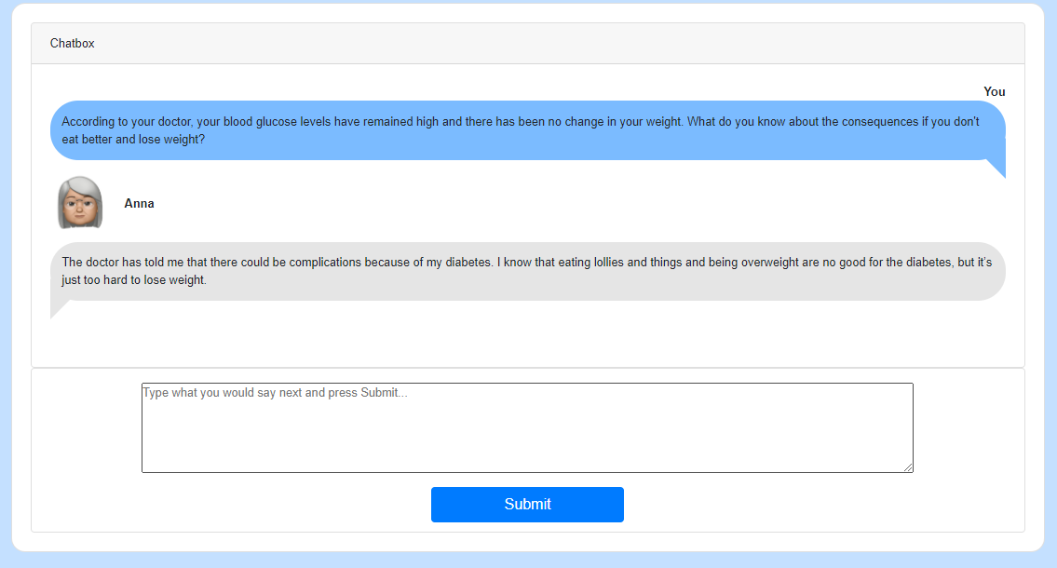
At this point, we would again type in the next thing we would say and then select from the four subsequently presented options. In this way, we continue to interview Anna until the interview comes to a natural end (the software will indicate this, and in the current conversation this usually occurs after about 10 or 11 turns):
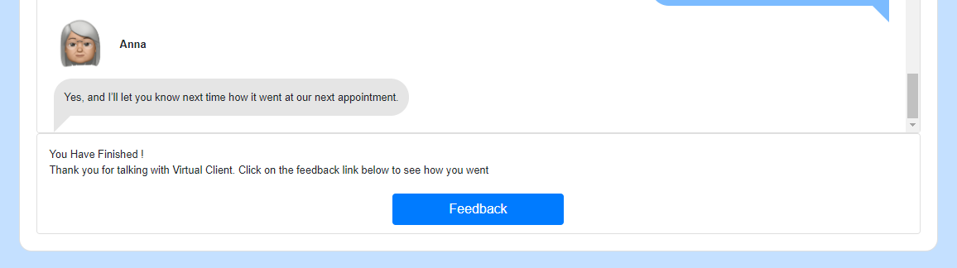
Receiving Feedback on your interview
Click on Feedback to view a reprisal of the conversation with Anna, annotated with feedback to indicate how appropriate your selected response were in terms of MI principles.
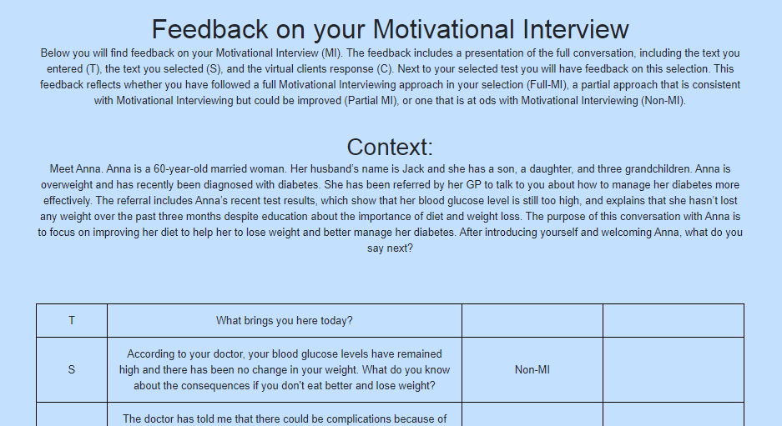
Resetting your conversation attempts
By default, current settings allow you to interview Anna once only. However, it is easy to “reset” your conversation attempt, so that you can conduct another interview. To do this, click on Dashboard, and then click on your name (displayed at the top right of the screen).
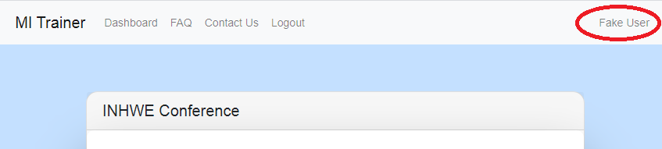
This will lead to a page on which there are two panels. The second of these contains the text “Reset Chat Attempts”. Click on Reset to reset conversations and start again.
